Chemistry, 7e (McMurry/Fay)
Chapter 1 Chemical Tools: Experimentation and Measurement

1.1 Multiple-Choice Questions

1) A consistent explanation of known observations is called
A) an experiment.
B) a hypothesis.
C) a prediction.
D) a theory.
Answer: D
Diff: 1 Var: 1
Topic: Section 1.1 The Scientific Method in a Chemical Content: Improved Pharmaceutical Insulin
Learning Obj: LO 1.1 Identify the steps in the scientific method.
Global Obj: G1 Demonstrate an understanding of the principles of scientific inquiry.

2) An interpretation of the results of many tests is called
A) an experiment.
B) a hypothesis.
C) a prediction.
D) a theory.
Answer: B
Diff: 1 Var: 1
Topic: Section 1.1 The Scientific Method in a Chemical Content: Improved Pharmaceutical Insulin
Learning Obj: LO 1.1 Identify the steps in the scientific method.
Global Obj: G1 Demonstrate an understanding of the principles of scientific inquiry.

3) Which of the following is an example of a qualitative measurement?
A) blue crystal
B) 10 g of salt
C) 2 moles of carbon atoms
D) 12 dL of water
Answer: A
Diff: 2 Var: 1
Topic: Section 1.1 The Scientific Method in a Chemical Content: Improved Pharmaceutical Insulin
Learning Obj: LO 1.1 Identify the steps in the scientific method.
Global Obj: G2 Demonstrate the ability to think critically and employ critical thinking skills.

4) What symbol is used to express the factor, 10-6?
A) M
B) m
C) μ
D) n
Answer: C
Diff: 1 Var: 1
Topic: Section 1.2 Experimentation and Measurement
Learning Obj: LO 1.3 Write numbers in scientific notation and use prefixes for multiples of SI units.
Global Obj: G1 Demonstrate an understanding of the principles of scientific inquiry.
5) What symbol is used to represent the factor 10-3?
A) M
B) m
C) μ
D) n
Answer: B
Diff: 1 Var: 1
Topic: Section 1.2 Experimentation and Measurement
Learning Obj: LO 1.3 Write numbers in scientific notation and use prefixes for multiples of SI units.
Global Obj: G1 Demonstrate an understanding of the principles of scientific inquiry.

6) The factor 0.01 corresponds to which prefix?
A) deka
B) deci
C) centi
D) milli
Answer: C
Diff: 1 Var: 1
Topic: Section 1.2 Experimentation and Measurement
Learning Obj: LO 1.3 Write numbers in scientific notation and use prefixes for multiples of SI units.
Global Obj: G1 Demonstrate an understanding of the principles of scientific inquiry.

7) The factor 10-2 corresponds to which prefix?
A) deka
B) deci
C) centi
D) milli
Answer: C
Diff: 1 Var: 1
Topic: Section 1.2 Experimentation and Measurement
Learning Obj: LO 1.3 Write numbers in scientific notation and use prefixes for multiples of SI units.
Global Obj: G1 Demonstrate an understanding of the principles of scientific inquiry.

8) A sailor circumnavigated the earth and covered 4,264,000 meters. Express this number in standard scientific notation.
A) 4.264 × 10-7 m
B) 4.264 × 10-6 m
C) 4.264 × 106 m
D) 4.264 × 107 m
Answer: C
Diff: 1 Var: 1
Topic: Section 1.2 Experimentation and Measurement
Learning Obj: LO 1.3 Write numbers in scientific notation and use prefixes for multiples of SI units.
Global Obj: G4 Demonstrate the quantitative skills needed to succeed in chemistry and G5 Demonstrate an understanding of the impact of science on society.
9) Without using a calculator, solve the following problem:

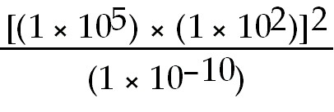

A) 1 × 10-6
B) 1 × 104
C) 1 × 1024
D) 1 × 1034
Answer: C
Diff: 2 Var: 1
Topic: Section 1.2 Experimentation and Measurement
Learning Obj: LO 1.3 Write numbers in scientific notation and use prefixes for multiples of SI units.
Global Obj: G4 Demonstrate the quantitative skills needed to succeed in chemistry.

10) Without using a calculator, solve the following problem:

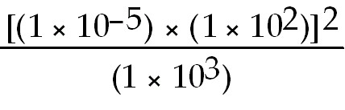

A) 1 × 100
B) 1 × 10-3
C) 1 × 10-9
D) 1 × 10-12
Answer: C
Diff: 2 Var: 1
Topic: Section 1.2 Experimentation and Measurement
Learning Obj: LO 1.3 Write numbers in scientific notation and use prefixes for multiples of SI units.
Global Obj: G4 Demonstrate the quantitative skills needed to succeed in chemistry.

11) An astronaut uses a laboratory balance and weighs an object on earth and again on the moon. Which statement below about the weight and mass of the object is true?
A) The mass and weight will be identical on the earth and the moon.
B) The mass will be the same on earth and moon but the weight will be less on the moon.
C) The weight will be the same on earth and moon but the mass will be less on the moon.
D) Both the mass and weight will be different on earth and moon.
Answer: B
Diff: 1 Var: 1
Topic: Section 1.3 Mass and Its Measurement
Learning Obj: LO 1.4 Describe the difference between mass and weight.
Global Obj: G2 Demonstrate the ability to think critically and employ critical thinking skills and G5 Demonstrate an understanding of the impact of science on society.
12) When measuring a solid metal block at constant temperature, which measurement will change in numerical value depending on the location where it is taken?
A) length
B) mass
C) volume
D) weight
Answer: D
Diff: 1 Var: 1
Topic: Section 1.3 Mass and Its Measurement
Learning Obj: LO 1.4 Describe the difference between mass and weight.
Global Obj: G2 Demonstrate the ability to think critically and employ critical thinking skills.

13) One kilogram is slightly more than ________ U.S. pounds.
A) 0.5
B) 1
C) 2
D) 5
Answer: C
Diff: 1 Var: 1
Topic: Section 1.3 Mass and Its Measurement
Learning Obj: LO 1.5 Convert between different prefixes used in mass measurements.
Global Obj: G4 Demonstrate the quantitative skills needed to succeed in chemistry.

14) One gram is approximately the same as half the mass of a new U.S.
A) penny.
B) dime.
C) quarter.
D) dollar.
Answer: B
Diff: 1 Var: 1
Topic: Section 1.3 Mass and Its Measurement
Learning Obj: LO 1.5 Convert between different prefixes used in mass measurements.
Global Obj: G4 Demonstrate the quantitative skills needed to succeed in chemistry.

15) The mass of a proton is 1.67 × 10-27 kg. What is the mass of a proton in Gigagrams?
A) 1.67 × 10-39 Gg
B) 1.67 × 10-36 Gg
C) 1.67 × 10-33 Gg
D) 1.67 × 10-30 Gg
Answer: C
Diff: 1 Var: 1
Topic: Section 1.3 Mass and Its Measurement
Learning Obj: LO 1.5 Convert between different prefixes used in mass measurements.
Global Obj: G4 Demonstrate the quantitative skills needed to succeed in chemistry.
16) The number of cm in 1.0 in is closest to
A) 1.0.
B) 1.5.
C) 2.0.
D) 2.5.
Answer: D
Diff: 1 Var: 1
Topic: Section 1.4 Length and Its Measurement
Learning Obj: LO 1.6 Convert between different prefixes used in length measurements.
Global Obj: G4 Demonstrate the quantitative skills needed to succeed in chemistry.

17) The thickness of a U.S. dime is approximately one
A) m.
B) cm.
C) mm.
D) μm.
Answer: C
Diff: 1 Var: 1
Topic: Section 1.4 Length and Its Measurement
Learning Obj: LO 1.6 Convert between different prefixes used in length measurements.
Global Obj: G4 Demonstrate the quantitative skills needed to succeed in chemistry.

18) The diameter of an atom is approximately 1 × 10-10 m. What is the diameter in millimeters?
A) 1 × 10-16 mm
B) 1 × 10-13 mm
C) 1 × 10-7 mm
D) 1 × 10-4 mm
Answer: C
Diff: 1 Var: 1
Topic: Section 1.4 Length and Its Measurement
Learning Obj: LO 1.6 Convert between different prefixes used in length measurements.
Global Obj: G4 Demonstrate the quantitative skills needed to succeed in chemistry.

19) The diameter of the nucleus of an atom is approximately 1 × 10-15 meters. If 1 nm is equal to 10 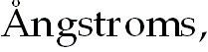 what is the diameter of the nucleus in 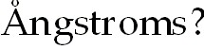
A) 1 × 10-23 Å
B) 1 × 10-8 Å
C) 1 × 10-7 Å
D) 1 × 10-5 Å
Answer: D
Diff: 1 Var: 1
Topic: Section 1.4 Length and Its Measurement
Learning Obj: LO 1.6 Convert between different prefixes used in length measurements.
Global Obj: G4 Demonstrate the quantitative skills needed to succeed in chemistry.
20) What is the coldest temperature possible?
A) 0°C
B) 0°F
C) 0 K
D) None of these
Answer: C
Diff: 2 Var: 1
Topic: Section 1.5 Temperature and Its Measurement
Learning Obj: LO 1.7 Convert between common units of temperature measurements.
Global Obj: G4 Demonstrate the quantitative skills needed to succeed in chemistry.

21) If the melting point of titanium metal is 1672°C, what is its melting point in Kelvin?
A) 897 K
B) 1399 K
C) 1945 K
D) 3042 K
Answer: C
Diff: 2 Var: 1
Topic: Section 1.5 Temperature and Its Measurement
Learning Obj: LO 1.7 Convert between common units of temperature measurements.
Global Obj: G4 Demonstrate the quantitative skills needed to succeed in chemistry.

22) Which one of the following statements about temperature scales is false?
A) The boiling point of water on the Fahrenheit scale is 212 degrees.
B) The Celsius degree is smaller than the Fahrenheit degree.
C) The freezing point of water on the Celsius scale is 0 degrees.
D) All temperatures on the Kelvin scale are positive numbers.
Answer: B
Diff: 2 Var: 1
Topic: Section 1.5 Temperature and Its Measurement
Learning Obj: LO 1.7 Convert between common units of temperature measurements.
Global Obj: G4 Demonstrate the quantitative skills needed to succeed in chemistry.

23) The freezing point of methane is -295°F and the boiling point is -263°F. The temperature of the surface of Titan, a moon of Saturn, is 93 K. If methane exists on Titan, it is
A) a gas.
B) a liquid.
C) a solid.
D) a plasma.
Answer: B
Diff: 2 Var: 1
Topic: Section 1.5 Temperature and Its Measurement
Learning Obj: LO 1.7 Convert between common units of temperature measurements.
Global Obj: G4 Demonstrate the quantitative skills needed to succeed in chemistry.
24) The nighttime and daytime temperatures on Mercury are 13 K and 683 K respectively. The melting point and boiling point of sulfur is 246°F and 832°F. Which of the following statements is true? On Mercury sulfur exists
A) only in the liquid state.
B) only in the solid state.
C) as both a liquid and a gas.
D) as both a liquid and a solid.
Answer: D
Diff: 2 Var: 1
Topic: Section 1.5 Temperature and Its Measurement
Learning Obj: LO 1.7 Convert between common units of temperature measurements.
Global Obj: G4 Demonstrate the quantitative skills needed to succeed in chemistry.

25) Which of the following correctly ranks the following temperatures from smallest to largest?

23°C, 17°F, 273K, 1°C

A) 23°C < 17°F < 273K < 1°C
B) 1°C < 17°F < 23°C < 273K
C) 273K < 23°C < 1°C < 17°F
D) 17°F < 273K < 1°C < 23°C
Answer: D
Diff: 2 Var: 1
Topic: Section 1.5 Temperature and Its Measurement
Learning Obj: LO 1.7 Convert between common units of temperature measurements.
Global Obj: G4 Demonstrate the quantitative skills needed to succeed in chemistry.

26) The temperature scales of Kelvin, Celsius, and Fahrenheit use different ways to define scale. Which of the following correctly ranks the temperature from smallest to largest?

0°C, 0°F, 0K

A) 0K < 0°C < 0°F
B) 0°C < 0K < 0°F
C) 0K < 0°F < 0°C
D) 0°C = 0K = 0°F
Answer: C
Diff: 2 Var: 1
Topic: Section 1.5 Temperature and Its Measurement
Learning Obj: LO 1.7 Convert between common units of temperature measurements.
Global Obj: G4 Demonstrate the quantitative skills needed to succeed in chemistry.

27) One liter is approximately the same as one U.S.
A) ounce.
B) pint.
C) quart.
D) gallon.
Answer: C
Diff: 1 Var: 1
Topic: Section 1.6 Derived Units: Volume and Its Measurement
Learning Obj: LO 1.8 Convert between SI and metric units of volume.
Global Obj: G4 Demonstrate the quantitative skills needed to succeed in chemistry.
28) Pyrite is called fool's gold because it looks like real gold. However, pyrite has a density of 4.5 g/mL while gold has a density of 19.3 g/mL. Use this information to determine which of the following statements is true.
A) 25 grams of gold will occupy a greater volume than 25 grams of pyrite.
B) 25 grams of gold will occupy the same volume as 25 grams of pyrite.
C) 25 mL of gold will have a greater mass than 25 mL of pyrite.
D) 25 mL of gold will have less mass than 25 mL of pyrite.
Answer: C
Diff: 2 Var: 1
Topic: Section 1.7 Derived Units: Density and Its Measurement
Learning Obj: LO 1.10a Calculate mass, volume, or density using the formula for density.
Global Obj: G4 Demonstrate the quantitative skills needed to succeed in chemistry.

29) The density of aluminum is 2.702 g/cm3. What is the final liquid level of water if 1.130 ounces of aluminum is dropped into a graduated cylinder containing 15.90 mL of water?
A) 17.08 mL
B) 21.66 mL
C) 27.76 mL
D) 47.95 mL
Answer: C
Diff: 2 Var: 1
Topic: Section 1.7 Derived Units: Density and Its Measurement
Learning Obj: LO 1.10a Calculate mass, volume, or density using the formula for density.
Global Obj: G4 Demonstrate the quantitative skills needed to succeed in chemistry.

30) The density of mercury is 13.5 g/mL. What is the mass in kg of mercury that fills a 0.250 L flask?
A) 0.0540 kg
B) 3.38 kg
C) 54.0 kg
D) 3380 kg
Answer: B
Diff: 2 Var: 1
Topic: Section 1.7 Derived Units: Density and Its Measurement
Learning Obj: LO 1.10a Calculate mass, volume, or density using the formula for density.
Global Obj: G4 Demonstrate the quantitative skills needed to succeed in chemistry.

31) The density of copper is 8.96 g/cm3. What is the mass in mg of a cube of copper that measures 2.31 mm on each side?
A) 0.0207 g
B) 0.110 g
C) 2.07 g
D) 110 g
Answer: B
Diff: 2 Var: 1
Topic: Section 1.7 Derived Units: Density and Its Measurement
Learning Obj: LO 1.10a Calculate mass, volume, or density using the formula for density.
Global Obj: G4 Demonstrate the quantitative skills needed to succeed in chemistry.
32) A gold ingot weighs 5.50 lbs. If the density of gold is 19.31 g/cm3, and the length and width of the ingot are 12.0 cm and 3.00 cm respectively, what is the height of the ingot?
A) 6.50 × 10-3 cm
B) 3.59 cm
C) 10.2 cm
D) 1.34 × 103 cm
Answer: B
Diff: 2 Var: 1
Topic: Section 1.7 Derived Units: Density and Its Measurement
Learning Obj: LO 1.10a Calculate mass, volume, or density using the formula for density.
Global Obj: G4 Demonstrate the quantitative skills needed to succeed in chemistry.

33) The estimated mass of the planet Jupiter is 1.90 × 1027 kg and the density is believed to be 1.34 g/cm3. If Jupiter were a perfect sphere, what would be its diameter?
A) 6.96 × 106 m
B) 6.96 × 107 m
C) 1.39 × 107 m
D) 1.39 × 108 m
Answer: D
Diff: 4 Var: 1
Topic: Section 1.7 Derived Units: Density and Its Measurement
Learning Obj: LO 1.10a Calculate mass, volume, or density using the formula for density.
Global Obj: G4 Demonstrate the quantitative skills needed to succeed in chemistry.

34) The volume of a well is 40.0 ft3. How many kilograms of concrete will it take to fill the well if the density of concrete is 2.85 g/cm3?
A) 3.47 kg
B) 3.23 × 103 kg
C) 3.47 × 103 kg
D) 3.23 × 106 kg
Answer: B
Diff: 2 Var: 1
Topic: Section 1.7 Derived Units: Density and Its Measurement
Learning Obj: LO 1.10a Calculate mass, volume, or density using the formula for density.
Global Obj: G4 Demonstrate the quantitative skills needed to succeed in chemistry.

35) Because of the high heat and low humidity in the summer in Death Valley, California, a visitor requires about one quart of water for every two miles traveled on foot. If the density of water is 0.990 g/mL at 45°C, how many kilograms of water are required for a person to walk 30 kilometers in Death Valley?
A) 8.7 kg
B) 70 kg
C) 3.5 × 102 kg
D) 7.0 × 102 kg
Answer: A
Diff: 3 Var: 1
Topic: Section 1.7 Derived Units: Density and Its Measurement
Learning Obj: LO 1.10a Calculate mass, volume, or density using the formula for density.
Global Obj: G4 Demonstrate the quantitative skills needed to succeed in chemistry and G5 Demonstrate an understanding of the impact of science on society.
36) Specific gravity of a liquid is often defined as the ratio of the density of a substance to the density of water. If the specific gravity of X relative to water is 0.800 and the specific gravity of Y relative to water is 1.50, which of the following statements is false?
A) If X is a liquid, Y will float on X.
B) If X is a solid, X will float in water.
C) If Y is a liquid, water will float on Y.
D) If Y is a liquid, X will float in Y.
Answer: A
Diff: 2 Var: 1
Topic: Section 1.7 Derived Units: Density and Its Measurement
Learning Obj: LO 1.11 Predict whether a substance will float or sink in another substance based on density.
Global Obj: G4 Demonstrate the quantitative skills needed to succeed in chemistry.

37) A piece of plastic weighing 1.157 g has a volume of 1.48 cm3. A piece of wood has the same volume but weighs 3.85 g. The density of liquid X is 0.765 g/mL and the density of liquid Z is 1.13 g/mL. The two liquids are immiscible. If the plastic and wood are added to the two liquids, what is the order of layers from top to bottom in the container?
A) liquid X, liquid Z, plastic, wood
B) liquid X, plastic, liquid Z, wood
C) plastic, wood, liquid Z, liquid X
D) wood, liquid Z, plastic, liquid X
Answer: B
Diff: 2 Var: 1
Topic: Section 1.7 Derived Units: Density and Its Measurement
Learning Obj: LO 1.11 Predict whether a substance will float or sink in another substance based on density.
Global Obj: G4 Demonstrate the quantitative skills needed to succeed in chemistry.

38) Calculate the kinetic energy of a 150-g baseball moving at a speed of 40. m/s (89 mph).
A) 6.0 J
B) 1.2 × 102 J
C) 6.0 × 103 J
D) 1.2 × 105 J
Answer: B
Diff: 2 Var: 1
Topic: Section 1.8 Derived Units: Energy and Its Measurement
Learning Obj: LO 1.12 Calculate the kinetic energy of a moving object.
Global Obj: G4 Demonstrate the quantitative skills needed to succeed in chemistry.

39) The average mass of an oxygen atom is 5.3 × 10-26 kg. Calculate the kinetic energy of a mole of oxygen atoms, all moving at a speed of 400 m/s (1000 mph).
A) 8.2 × 10-21 J
B) 2600 J
C) 5200 J
D) 13,000 J
Answer: B
Diff: 2 Var: 1
Topic: Section 1.8 Derived Units: Energy and Its Measurement
Learning Obj: LO 1.12 Calculate the kinetic energy of a moving object.
Global Obj: G4 Demonstrate the quantitative skills needed to succeed in chemistry.
40) Which has the least kinetic energy?
A) a 1200 kg object moving at 90 km/hr
B) a 1400 kg object moving at 85 km/hr
C) a 1600 kg object moving at 80 km/hr
D) a 1800 kg object moving at 75 km/hr
Answer: A
Diff: 2 Var: 1
Topic: Section 1.8 Derived Units: Energy and Its Measurement
Learning Obj: LO 1.12 Calculate the kinetic energy of a moving object.
Global Obj: G4 Demonstrate the quantitative skills needed to succeed in chemistry.

41) How many significant figures are there in the answer to the following problem?

(8.881 × 2.100) + 0.590 = ?

A) one
B) two
C) three
D) four
Answer: D
Diff: 2 Var: 1
Topic: Section 1.10 Rounding Numbers
Learning Obj: LO 1.17 Report the answer of mathematical calculations to the correct number of significant numbers.
Global Obj: G4 Demonstrate the quantitative skills needed to succeed in chemistry.

42) How many significant figures are there in the answer for the following problem?

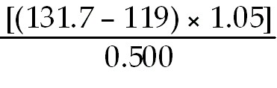 = ?

A) one
B) two
C) three
D) four
Answer: B
Diff: 2 Var: 1
Topic: Section 11.8 Structures of Some Covalent Network Solids
Learning Obj: LO 1.17 Report the answer of mathematical calculations to the correct number of significant numbers.
Global Obj: G4 Demonstrate the quantitative skills needed to succeed in chemistry.
43) Each of the numbers in the following calculation represents a quantity measured by a student in the laboratory.

P = 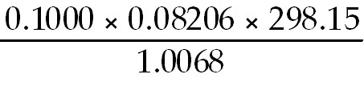

After performing the calculation, the student's calculator appeared as shown below:
To the correct number of significant figures what is the value of P?

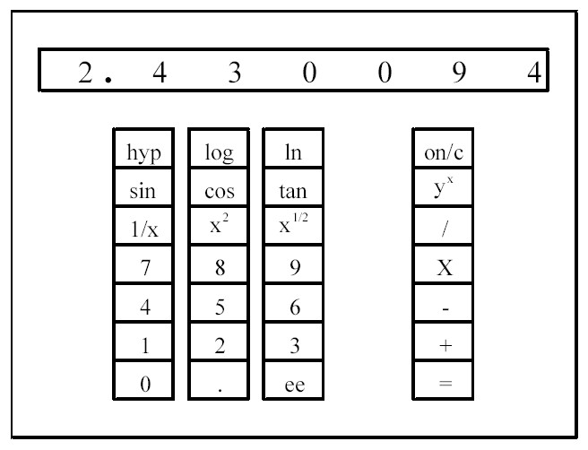

A) 2
B) 2.43
C) 2.430
D) 2.430094
Answer: C
Diff: 2 Var: 1
Topic: Section 1.10 Rounding Numbers
Learning Obj: LO 1.17 Report the answer of mathematical calculations to the correct number of significant numbers.
Global Obj: G4 Demonstrate the quantitative skills needed to succeed in chemistry.
44) Each of the numbers in the following calculation represents a quantity measured by a student in the laboratory.

g = 0.0220 × 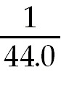 × 12.0

After performing the calculation, the student's calculator appeared as shown below:
To the correct number of significant figures what is the value of g?

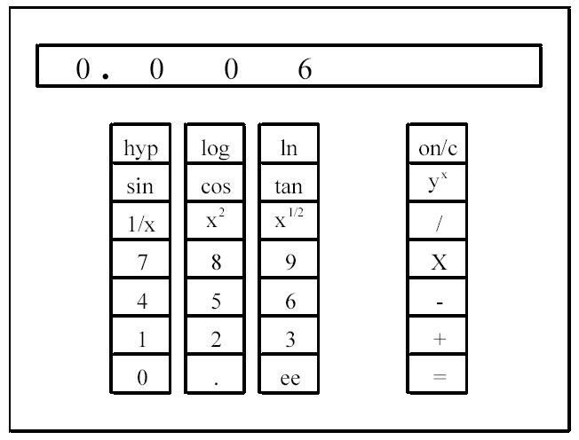

A) 6 × 10-3
B) 6.0 × 10-3
C) 6.00 × 10-3
D) 6.000 × 10-3
Answer: C
Diff: 2 Var: 1
Topic: Section 1.10 Rounding Numbers
Learning Obj: LO 1.17 Report the answer of mathematical calculations to the correct number of significant numbers.
Global Obj: G4 Demonstrate the quantitative skills needed to succeed in chemistry.

45) To the correct number of significant figures, an automobile traveling at 28 mi/h is traveling at ________ km/h (1 km = 0.6214 mi).
A) 17
B) 17.40
C) 45
D) 45.06
Answer: C
Diff: 2 Var: 1
Topic: Section 1.11 Calculations: Converting from One Unit to Another
Learning Obj: LO 1.19 Change a measurement into different units using appropriate conversion factors.
Global Obj: G4 Demonstrate the quantitative skills needed to succeed in chemistry.
46) An automobile uses gasoline at a rate of 35 mi/gal, which is the same as ________ km/L (1 km = 0.6214 mi, 1 gal = 3.78 L).
A) 5.8
B) 15
C) 82
D) 210
Answer: B
Diff: 2 Var: 1
Topic: Section 1.11 Calculations: Converting from One Unit to Another
Learning Obj: LO 1.19 Change a measurement into different units using appropriate conversion factors.
Global Obj: G4 Demonstrate the quantitative skills needed to succeed in chemistry.

47) If 1.4% of the mass of a human body is calcium, how many kilograms of calcium are there in a 173-pound man?
A) 1.1 kg Ca
B) 5.3 kg Ca
C) 1.1 × 102 kg Ca
D) 5.3 × 102 kg Ca
Answer: A
Diff: 2 Var: 1
Topic: Section 1.11 Calculations: Converting from One Unit to Another
Learning Obj: LO 1.19 Change a measurement into different units using appropriate conversion factors.
Global Obj: G4 Demonstrate the quantitative skills needed to succeed in chemistry.

48) A fishing boat accidentally spills 15 barrels of diesel oil into the ocean. Each barrel contains 42 gallons. If the oil film on the ocean is 2.5 × 102 nm thick, how many square meters will the oil slick cover?
A) 9.5 × 10-3 m2
B) 9.5 × 106 m2
C) 9.5 × 107 m2
D) none of these
Answer: B
Diff: 3 Var: 1
Topic: Section 1.11 Calculations: Converting from One Unit to Another
Learning Obj: LO 1.19 Change a measurement into different units using appropriate conversion factors.
Global Obj: G4 Demonstrate the quantitative skills needed to succeed in chemistry.
49) An international group of zookeepers with successful breeding programs made the following animal exchanges last year. Using the same bartering system, how many oryxes can a zoo obtain in exchange for 15 flamingos?

3 oryxes = 1 tiger 2 flamingos = 1 anteater
1 camel = 6 anteaters 5 lemurs = 1 rhino
1 rhino = 4 monkeys 3 lemurs = 1 camel
3 monkeys = 1 tiger 1 rhino = 4 oryxes

A) one oryx
B) three oryxes
C) four oryxes
D) five oryxes
Answer: B
Diff: 3 Var: 1
Topic: Section 1.11 Calculations: Converting from One Unit to Another
Learning Obj: LO 1.19 Change a measurement into different units using appropriate conversion factors.
Global Obj: G4 Demonstrate the quantitative skills needed to succeed in chemistry.

50) You are visiting the planet Lagmom. The money exchange rates are shown below. How many Lagmom fizzbarts will you receive in exchange for $500 at the Lagmom Spaceport Currency Exchange counter?

$1.00 = 10 razz 1 morb = 25 pobs
5 pobs = 1 fizzbart 5 razz = 1 tanta
1 tanta = 2 morbs

A) 5.00 × 102 fizzbarts
B) 1.00 × 103 fizzbarts
C) 1.00 × 104 fizzbarts
D) 5.00 × 105 fizzbarts
Answer: C
Diff: 3 Var: 1
Topic: Section 1.11 Calculations: Converting from One Unit to Another
Learning Obj: LO 1.19 Change a measurement into different units using appropriate conversion factors.
Global Obj: G4 Demonstrate the quantitative skills needed to succeed in chemistry.

51) Because of the high heat and low humidity in the summer in Death Valley, California, a visitor requires about one quart of water for every two miles traveled on foot. Calculate the approximate number of liters required for a person to walk 30. kilometers in Death Valley.
A) 8.8 L
B) 35 L
C) 91 L
D) 140 L
Answer: A
Diff: 3 Var: 1
Topic: Section 1.11 Calculations: Converting from One Unit to Another
Learning Obj: LO 1.19 Change a measurement into different units using appropriate conversion factors.
Global Obj: G4 Demonstrate the quantitative skills needed to succeed in chemistry and G5 Demonstrate an understanding of the impact of science on society.
52) A college runner set a school record of 3:59.37 in the mile run. Assuming that the distance was measured accurately to five significant figures, what was the runner's average speed in kilometers per hour?
A) 9.3454 km/hr
B) 10.375 km/hr
C) 24.203 km/hr
D) 26.869 km/hr
Answer: C
Diff: 3 Var: 1
Topic: Section 1.11 Calculations: Converting from One Unit to Another
Learning Obj: LO 1.19 Change a measurement into different units using appropriate conversion factors.
Global Obj: G4 Demonstrate the quantitative skills needed to succeed in chemistry.

53) The winner of the men's 1500-meter speed skating event at a recent Winter Olympics had a time of 1:45.57. Assuming that the distance was measured accurately to five significant figures, what was the skater's average speed in miles per hour?
A) 31.790 mi/hr
B) 38.418 mi/hr
C) 51.151 mi/hr
D) 61.826 mi/hr
Answer: A
Diff: 3 Var: 1
Topic: Section 1.11 Calculations: Converting from One Unit to Another
Learning Obj: LO 1.19 Change a measurement into different units using appropriate conversion factors.
Global Obj: G4 Demonstrate the quantitative skills needed to succeed in chemistry and G5 Demonstrate an understanding of the impact of science on society.

54) A motorcycle emits 9.5 g of carbon monoxide per kilometer driven. How many pounds of carbon monoxide does the motorcycle generate over 5.0 years if the motorcycle is driven 15,000 miles per year?
A) 8.9 × 101 lb CO
B) 9.8 × 102 lb CO
C) 2.5 × 103 lb CO
D) 2.3 × 104 lb CO
Answer: C
Diff: 3 Var: 1
Topic: Section 1.11 Calculations: Converting from One Unit to Another
Learning Obj: LO 1.19 Change a measurement into different units using appropriate conversion factors.
Global Obj: G4 Demonstrate the quantitative skills needed to succeed in chemistry and G5 Demonstrate an understanding of the impact of science on society.
55) The temperature of 1.00 mL of water is raised by 1.00°C for every 4.184 joules of heat absorbed by the water. How many liters of water can be raised from 21.0°C to 100.0°C by the absorption of 8.88 kcal of heat generated by the combustion of natural gas?
A) 0.112 L
B) 2.13 L
C) 37.2 L
D) 168 L
Answer: A
Diff: 3 Var: 1
Topic: Section 1.11 Calculations: Converting from One Unit to Another
Learning Obj: LO 1.19 Change a measurement into different units using appropriate conversion factors.
Global Obj: G4 Demonstrate the quantitative skills needed to succeed in chemistry.

56) Combustion of hydrogen releases 142 kJ per gram of hydrogen reacted. How many kilocalories of energy are released by the combustion of 16.0 ounces of hydrogen?
A) 1.31 kcal
B) 19.2 kcal
C) 1.54 × 104 kcal
D) 2.69 × 105 kcal
Answer: C
Diff: 3 Var: 1
Topic: Section 1.11 Calculations: Converting from One Unit to Another
Learning Obj: LO 1.19 Change a measurement into different units using appropriate conversion factors.
Global Obj: G4 Demonstrate the quantitative skills needed to succeed in chemistry.

57) When 1.0 gram of hydrogen reacts with 8.0 grams of oxygen 9.0 grams of water are produced and 142 kJ of heat are released. How many grams of hydrogen and how many grams of oxygen must react to produce 250 kJ of heat?
A) 0.57 g H2 and 4.5 g O2
B) 0.57 g H2 and 14 g O2
C) 1.8 g H2 and 4.5 g O2
D) 1.8 g H2 and 14 g O2
Answer: D
Diff: 3 Var: 1
Topic: Section 1.11 Calculations: Converting from One Unit to Another
Learning Obj: LO 1.19 Change a measurement into different units using appropriate conversion factors.
Global Obj: G4 Demonstrate the quantitative skills needed to succeed in chemistry.

58) A tortoise moves at a speed of 454 cm/min. How fast is the tortoise in mph?
A) 0.17 mph
B) 0.34 mph
C) 17 mph
D) 0.0017 mph
Answer: A
Diff: 3 Var: 1
Topic: Section 1.11 Calculations: Converting from One Unit to Another
Learning Obj: LO 1.19 Change a measurement into different units using appropriate conversion factors.
Global Obj: G4 Demonstrate the quantitative skills needed to succeed in chemistry and G5 Demonstrate an understanding of the impact of science on society.
59) A pure diamond has a density of 3.52 g/cm3. Which of the following equations will allow you to correctly calculate the density in terms of kg/dm3?
A) 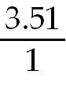 × 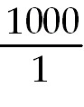 × 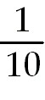
B) × 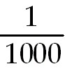 ×
C) × × 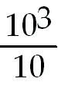
D) × × 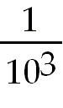
Answer: C
Diff: 3 Var: 1
Topic: Section 1.11 Calculations: Converting from One Unit to Another
Learning Obj: LO 1.19 Change a measurement into different units using appropriate conversion factors.
Global Obj: G4 Demonstrate the quantitative skills needed to succeed in chemistry and G5 Demonstrate an understanding of the impact of science on society.

60) A certain liquid has a density of 1.25 g/cm3. Which drawing below most closely represents the volume of this liquid needed to obtain 5.00 g of the liquid?

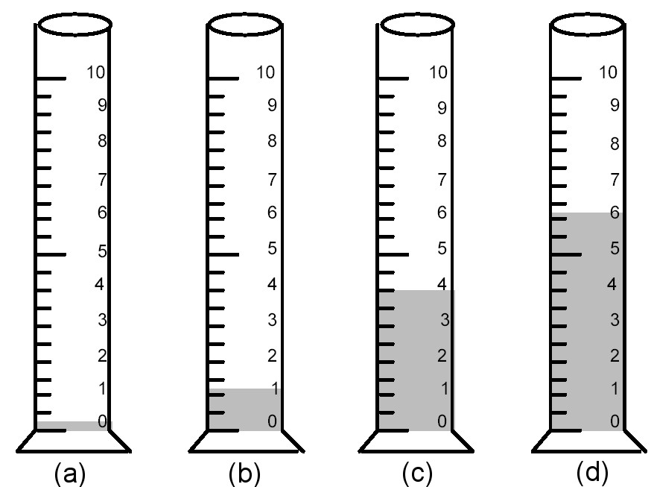

A) drawing (a)
B) drawing (b)
C) drawing (c)
D) drawing (d)
Answer: C
Diff: 3 Var: 1
Topic: Conceptual Problems
Learning Obj: LO 1.10a Calculate mass, volume, or density using the formula for density.
Global Obj: G3 Read and interpret graphs and data.
61) A certain solid has a density of 8.0 g/cm3. If 4.0 g of this solid are poured into 4.00 mL of water, which drawing below most closely represents the volume of water after the solid is added?

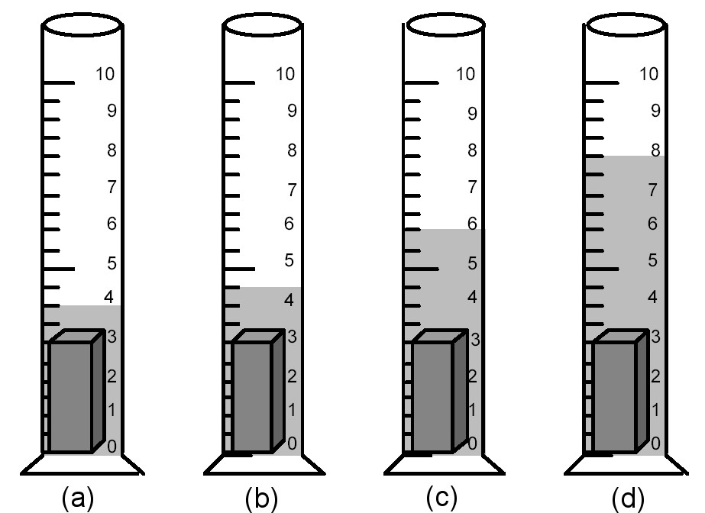

A) drawing (a)
B) drawing (b)
C) drawing (c)
D) drawing (d)
Answer: B
Diff: 3 Var: 1
Topic: Conceptual Problems
Learning Obj: LO 1.10a Calculate mass, volume, or density using the formula for density.
Global Obj: G3 Read and interpret graphs and data.
Use the drawings below to answer the following questions.

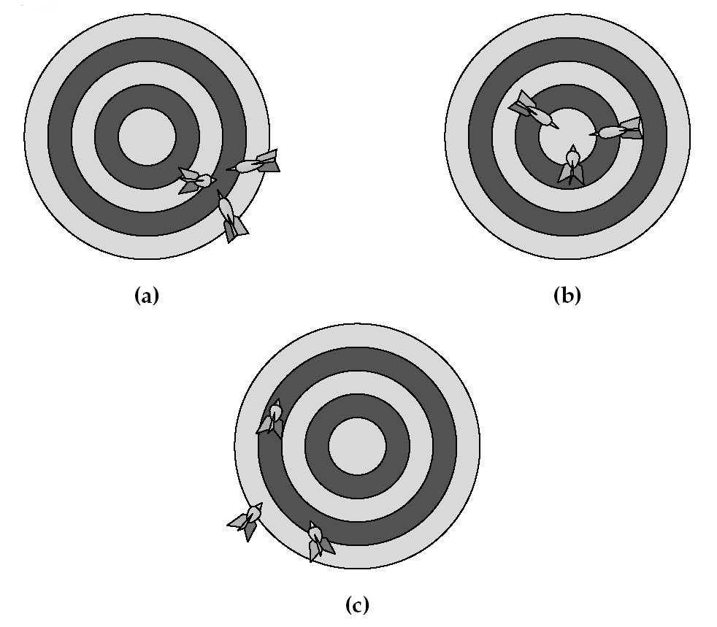
62) If hitting the bull's-eye is the desired result, Figure (a) represents
A) good accuracy and good precision.
B) good accuracy and poor precision.
C) poor accuracy and good precision.
D) poor accuracy and poor precision.
Answer: C
Diff: 2 Var: 1
Topic: Conceptual Problems
Learning Obj: LO 1.15 Evaluate the level of accuracy and precision in a data set.
Global Obj: G3 Read and interpret graphs and data.

63) If hitting the bull's-eye is the desired result, Figure (b) represents
A) good accuracy and good precision.
B) good accuracy and poor precision.
C) poor accuracy and good precision.
D) poor accuracy and poor precision.
Answer: A
Diff: 2 Var: 1
Topic: Conceptual Problems
Learning Obj: LO 1.15 Evaluate the level of accuracy and precision in a data set.
Global Obj: G3 Read and interpret graphs and data.
64) If hitting the bull's-eye is the desired result, Figure (c) represents
A) good accuracy and good precision.
B) good accuracy and poor precision.
C) poor accuracy and good precision.
D) poor accuracy and poor precision.
Answer: D
Diff: 2 Var: 1
Topic: Conceptual Problems
Learning Obj: LO 1.15 Evaluate the level of accuracy and precision in a data set.
Global Obj: G3 Read and interpret graphs and data.

65) To the correct number of significant figures, what is the temperature reading on the following Celsius thermometer?

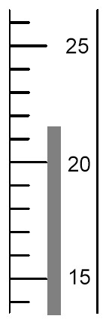

A) 21°C
B) 21.7°C
C) 21.70°C
D) 22°C
Answer: B
Diff: 2 Var: 1
Topic: Conceptual Problems
Learning Obj: LO 1.16 Report a measurement to the appropriate number of significant figures.
Global Obj: G3 Read and interpret graphs and data.
66) To the correct number of significant figures, what is the temperature reading on the following Celsius thermometer?

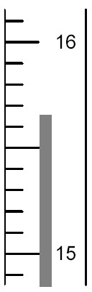

A) 15°C
B) 15.6°C
C) 15.67°C
D) 16°C
Answer: C
Diff: 2 Var: 1
Topic: Conceptual Problems
Learning Obj: LO 1.16 Report a measurement to the appropriate number of significant figures.
Global Obj: G3 Read and interpret graphs and data.

67) To the correct number of significant figures, what is the volume of the liquid in the graduated cylinder?

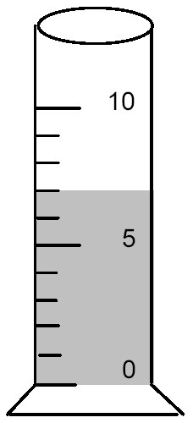

A) 7 mL
B) 7.0 mL
C) 7.7 mL
D) 8 mL
Answer: B
Diff: 2 Var: 1
Topic: Conceptual Problems
Learning Obj: LO 1.16 Report a measurement to the appropriate number of significant figures.
Global Obj: G3 Read and interpret graphs and data.
68) To the correct number of significant figures, what is the level of the liquid in the buret?

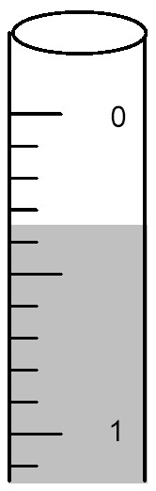

A) 0.2 mL
B) 0.29 mL
C) 0.3 mL
D) 0.35 mL
Answer: D
Diff: 2 Var: 1
Topic: Conceptual Problems
Learning Obj: LO 1.16 Report a measurement to the appropriate number of significant figures.
Global Obj: G3 Read and interpret graphs and data.

1.2 Algorithmic Questions

1) What symbol is used to represent the factor 10-2?
A) M
B) c
C) μ
D) n
Answer: B
Diff: 1 Var: 5
Topic: Section 1.2 Experimentation and Measurement
Learning Obj: LO 1.3 Write numbers in scientific notation and use prefixes for multiples of SI units.
Global Obj: G1 Demonstrate an understanding of the principles of scientific inquiry.

2) Which of the following is the smallest unit?
A) 13 centi
B) 3.0 deci
C) 3.3 × 103 milli
D) 1.5 × 106 nano
Answer: A
Diff: 1 Var: 50+
Topic: Section 1.2 Experimentation and Measurement
Learning Obj: LO 1.3 Write numbers in scientific notation and use prefixes for multiples of SI units.
Global Obj: G4 Demonstrate the quantitative skills needed to succeed in chemistry.
3) What symbol is used to represent the factor 109?
A) M
B) m
C) μ
D) G
Answer: D
Diff: 1 Var: 5
Topic: Section 1.2 Experimentation and Measurement
Learning Obj: LO 1.3 Write numbers in scientific notation and use prefixes for multiples of SI units.
Global Obj: G1 Demonstrate an understanding of the principles of scientific inquiry.

4) The factor 10 corresponds to which prefix?
A) centi
B) deci
C) deka
D) milli
Answer: C
Diff: 1 Var: 5
Topic: Section 1.2 Experimentation and Measurement
Learning Obj: LO 1.3 Write numbers in scientific notation and use prefixes for multiples of SI units.
Global Obj: G1 Demonstrate an understanding of the principles of scientific inquiry.

5) The factor 106 corresponds to which prefix?
A) deka
B) deci
C) mega
D) milli
Answer: C
Diff: 1 Var: 5
Topic: Section 1.2 Experimentation and Measurement
Learning Obj: LO 1.3 Write numbers in scientific notation and use prefixes for multiples of SI units.
Global Obj: G1 Demonstrate an understanding of the principles of scientific inquiry.

6) Without using a calculator, solve the following problem:

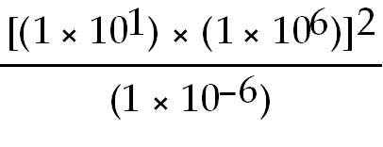

A) 1 × 102
B) 1 × 108
C) 1 × 1020
D) 1 × 1026
Answer: C
Diff: 2 Var: 5
Topic: Section 1.2 Experimentation and Measurement
Learning Obj: LO 1.3 Write numbers in scientific notation and use prefixes for multiples of SI units.
Global Obj: G4 Demonstrate the quantitative skills needed to succeed in chemistry.
7) Without using a calculator, solve the following problem:

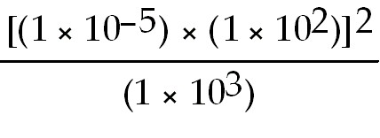

A) 1 × 100
B) 1 × 10-3
C) 1 × 10-9
D) 1 × 10-12
Answer: C
Diff: 2 Var: 5
Topic: Section 1.2 Experimentation and Measurement
Learning Obj: LO 1.3 Write numbers in scientific notation and use prefixes for multiples of SI units.
Global Obj: G4 Demonstrate the quantitative skills needed to succeed in chemistry.

8) The fundamental SI unit of mass is the
A) gigagram.
B) microgram.
C) kilogram.
D) decigram.
Answer: C
Diff: 1 Var: 50+
Topic: Section 1.2 Experimentation and Measurement
Learning Obj: LO 1.3 Write numbers in scientific notation and use prefixes for multiples of SI units.
Global Obj: G1 Demonstrate an understanding of the principles of scientific inquiry.

9) Which of the following is a fundamental SI Unit?
A) millimeter
B) meter
C) hectometer
D) nanometer
Answer: B
Diff: 1 Var: 50+
Topic: Section 1.2 Experimentation and Measurement
Learning Obj: LO 1.3 Write numbers in scientific notation and use prefixes for multiples of SI units.
Global Obj: G1 Demonstrate an understanding of the principles of scientific inquiry.

10) All of the following are fundamental SI units except the
A) year.
B) kilogram.
C) mole.
D) Kelvin.
Answer: A
Diff: 1 Var: 50+
Topic: Section 1.2 Experimentation and Measurement
Learning Obj: LO 1.3 Write numbers in scientific notation and use prefixes for multiples of SI units.
Global Obj: G1 Demonstrate an understanding of the principles of scientific inquiry.
11) What symbol is used to represent the factor 10-9?
A) G
B) c
C) μ
D) n
Answer: D
Diff: 1 Var: 50+
Topic: Section 1.2 Experimentation and Measurement
Learning Obj: LO 1.3 Write numbers in scientific notation and use prefixes for multiples of SI units.
Global Obj: G1 Demonstrate an understanding of the principles of scientific inquiry.

12) Convert 4.300 × 10-3 to ordinary notation.
A) 0.0004300
B) 0.004300
C) 430.0
D) 4300
Answer: B
Diff: 2 Var: 50+
Topic: Section 1.2 Experimentation and Measurement
Learning Obj: LO 1.3 Write numbers in scientific notation and use prefixes for multiples of SI units.
Global Obj: G4 Demonstrate the quantitative skills needed to succeed in chemistry.

13) Convert 0.009723 to standard scientific notation.
A) 9.723 × 10-3
B) 9723 × 10-6
C) 9.723 × 103
D) 9723 × 106
Answer: A
Diff: 2 Var: 50+
Topic: Section 1.2 Experimentation and Measurement
Learning Obj: LO 1.3 Write numbers in scientific notation and use prefixes for multiples of SI units.
Global Obj: G4 Demonstrate the quantitative skills needed to succeed in chemistry.

14) Which of the following is the greatest mass?
A) 10,000 μg
B) 1.000 × 10-3 kg
C) 1.000 × 10-3 cg
D) 1.000 × 10-7 Mg
Answer: B
Diff: 2 Var: 5
Topic: Section 1.3 Mass and Its Measurement
Learning Obj: LO 1.5 Convert between different prefixes used in mass measurements.
Global Obj: G4 Demonstrate the quantitative skills needed to succeed in chemistry.
15) The mass of a proton is 1.67 × 10-27 kg. What is the mass of a proton in Megagrams?
A) 1.67 × 10-36 Mg
B) 1.67 × 10-33 Mg
C) 1.67 × 10-30 Mg
D) 1.67 × 10-27 Mg
Answer: C
Diff: 2 Var: 5
Topic: Section 1.3 Mass and Its Measurement
Learning Obj: LO 1.5 Convert between different prefixes used in mass measurements.
Global Obj: G4 Demonstrate the quantitative skills needed to succeed in chemistry.

16) The mass of a single copper atom is 1.055 × 10-22 g. This is the same mass as
A) 1.055 × 10-16 mg.
B) 1.055 × 10-25 kg.
C) 1.055 × 10-28 μg.
D) 1.055 × 10-31 ng.
Answer: B
Diff: 2 Var: 5
Topic: Section 1.3 Mass and Its Measurement
Learning Obj: LO 1.5 Convert between different prefixes used in mass measurements.
Global Obj: G4 Demonstrate the quantitative skills needed to succeed in chemistry.

17) A student weighed 3.000 μg of sulfur in the lab. This is the same mass as
A) 3.000 × 10-9 g.
B) 3.000 × 10-6 kg.
C) 3.000 × 10-6 mg.
D) 3.000 × 103 ng.
Answer: D
Diff: 2 Var: 5
Topic: Section 1.3 Mass and Its Measurement
Learning Obj: LO 1.5 Convert between different prefixes used in mass measurements.
Global Obj: G4 Demonstrate the quantitative skills needed to succeed in chemistry.

18) Which of the following is the greatest mass?
A) 10 μg
B) 1.000 × 10-4 kg
C) 1.000 × 10-2 cg
D) 1.000 × 10-8 Mg
Answer: B
Diff: 2 Var: 50+
Topic: Section 1.3 Mass and Its Measurement
Learning Obj: LO 1.5 Convert between different prefixes used in mass measurements.
Global Obj: G4 Demonstrate the quantitative skills needed to succeed in chemistry.
19) The mass of a single copper atom is 1.055 × 10-22 g. This is the same mass as
A) 1.055 × 10-17 dg.
B) 1.055 × 10-28 mg.
C) 1.055 × 10-28 μg.
D) 1.055 × 10-33 pg.
Answer: B
Diff: 2 Var: 50+
Topic: Section 1.3 Mass and Its Measurement
Learning Obj: LO 1.5 Convert between different prefixes used in mass measurements.
Global Obj: G4 Demonstrate the quantitative skills needed to succeed in chemistry.

20) A student weighed 9000. μg of sulfur in the lab. This is the same mass as
A) 9.000 × 10-6 g.
B) 9.000 × 10-3 kg.
C) 9.000 × 102 cg.
D) 9.000 × 109 pg.
Answer: D
Diff: 2 Var: 50+
Topic: Section 1.3 Mass and Its Measurement
Learning Obj: LO 1.5 Convert between different prefixes used in mass measurements.
Global Obj: G4 Demonstrate the quantitative skills needed to succeed in chemistry.

21) Convert 1 μm to meters.
A) 1 × 10-9 m
B) 1 × 10-6 m
C) 1 × 10-3 m
D) 1 × 106 m
Answer: B
Diff: 2 Var: 5
Topic: Section 1.4 Length and Its Measurement
Learning Obj: LO 1.6 Convert between different prefixes used in length measurements.
Global Obj: G4 Demonstrate the quantitative skills needed to succeed in chemistry.

22) The average distance between nitrogen and oxygen atoms is 115 pm in a compound called nitric oxide. What is this distance in nanometers?
A) 1.15 × 10-2 nm
B) 1.15 × 10-1 nm
C) 1.15 × 1015 nm
D) 1.15 × 1019 nm
Answer: B
Diff: 2 Var: 5
Topic: Section 1.4 Length and Its Measurement
Learning Obj: LO 1.6 Convert between different prefixes used in length measurements.
Global Obj: G4 Demonstrate the quantitative skills needed to succeed in chemistry.
23) The diameter of an atom is approximately 1 × 10-10 m. What is the diameter in centimeters?
A) 1 × 10-13 cm
B) 1 × 10-12 cm
C) 1 × 10-8 cm
D) 1 × 10-7 cm
Answer: C
Diff: 2 Var: 5
Topic: Section 1.4 Length and Its Measurement
Learning Obj: LO 1.6 Convert between different prefixes used in length measurements.
Global Obj: G4 Demonstrate the quantitative skills needed to succeed in chemistry.

24) The diameter of the nucleus of an atom is approximately 1 × 10-13 cm. If 1 nm is equal to 10 what is the diameter of the nucleus in
A) 1 × 10-23 Å
B) 1 × 10-8 Å
C) 1 × 10-7 Å
D) 1 × 10-5 Å
Answer: D
Diff: 2 Var: 5
Topic: Section 1.4 Length and Its Measurement
Learning Obj: LO 1.6 Convert between different prefixes used in length measurements.
Global Obj: G4 Demonstrate the quantitative skills needed to succeed in chemistry.

25) Convert 5.0 μm to meters.
A) 5.0 × 10+9 m
B) 5.0 × 10-6 m
C) 5.0 × 10+3 m
D) 5.0 × 106 m
Answer: B
Diff: 2 Var: 50+
Topic: Section 1.4 Length and Its Measurement
Learning Obj: LO 1.6 Convert between different prefixes used in length measurements.
Global Obj: G4 Demonstrate the quantitative skills needed to succeed in chemistry.

26) The average distance between nitrogen and oxygen atoms is 115 pm in a compound called nitric oxide. What is this distance in centimeters?
A) 1.15 × 10-7 cm
B) 1.15 × 10-8 cm
C) 1.15 × 1013 cm
D) 1.15 × 1018 cm
Answer: B
Diff: 2 Var: 50+
Topic: Section 1.4 Length and Its Measurement
Learning Obj: LO 1.6 Convert between different prefixes used in length measurements.
Global Obj: G4 Demonstrate the quantitative skills needed to succeed in chemistry.
27) If the melting point of copper metal is 1085°C, what is its melting point in Kelvin?
A) 571 K
B) 812 K
C) 1358 K
D) 1985 K
Answer: C
Diff: 3 Var: 5
Topic: Section 1.5 Temperature and Its Measurement
Learning Obj: LO 1.7 Convert between common units of temperature measurements.
Global Obj: G4 Demonstrate the quantitative skills needed to succeed in chemistry.

28) Which of the following is the lowest temperature?
A) 37°C
B) 54°F
C) 313 K
D) All of these temperatures are all equal.
Answer: B
Diff: 3 Var: 5
Topic: Section 1.5 Temperature and Its Measurement
Learning Obj: LO 1.7 Convert between common units of temperature measurements.
Global Obj: G4 Demonstrate the quantitative skills needed to succeed in chemistry.

29) Which of the following is the lowest temperature?
A) 35°C
B) 57°F
C) 313 K
D) All of these temperatures are all equal.
Answer: B
Diff: 3 Var: 50+
Topic: Section 1.5 Temperature and Its Measurement
Learning Obj: LO 1.7 Convert between common units of temperature measurements.
Global Obj: G4 Demonstrate the quantitative skills needed to succeed in chemistry.

30) Which of the following volumes is equal to 50 mL?
A) 50 cm3
B) 50 dm3
C) 0.50 L
D) 0.00050 kL
Answer: A
Diff: 2 Var: 5
Topic: Section 1.6 Derived Units: Volume and Its Measurement
Learning Obj: LO 1.9 Convert between different prefixes used in volume measurements.
Global Obj: G4 Demonstrate the quantitative skills needed to succeed in chemistry.
31) Convert 10,000 cm3 to m3.
A) 1 × 10-2 m3
B) 1 × 102 m3
C) 1 × 106 m3
D) 1 × 1010 m3
Answer: A
Diff: 2 Var: 5
Topic: Section 1.6 Derived Units: Volume and Its Measurement
Learning Obj: LO 1.9 Convert between different prefixes used in volume measurements.
Global Obj: G4 Demonstrate the quantitative skills needed to succeed in chemistry.

32) Convert 55 m3 to liters.
A) 5.5 × 10-2 L
B) 5.5 L
C) 5.5 × 102 L
D) 5.5 × 104 L
Answer: D
Diff: 2 Var: 5
Topic: Section 1.6 Derived Units: Volume and Its Measurement
Learning Obj: LO 1.8 Convert between SI and metric units of volume.
Global Obj: G4 Demonstrate the quantitative skills needed to succeed in chemistry.

33) Which of the following is the smallest volume?
A) 11 cm3
B) 0.25 dL
C) 1.4 × 103 mL
D) 2.5 × 107 nL
Answer: A
Diff: 2 Var: 5
Topic: Section 1.6 Derived Units: Volume and Its Measurement
Learning Obj: LO 1.8 Convert between SI and metric units of volume.
Global Obj: G4 Demonstrate the quantitative skills needed to succeed in chemistry.

34) Which of the following volumes is equal to 60.0 mL?
A) 60.0 cm3
B) 60.0 mm3
C) 0.600 L
D) 0.000600 GL
Answer: A
Diff: 2 Var: 50+
Topic: Section 1.6 Derived Units: Volume and Its Measurement
Learning Obj: LO 1.8 Convert between SI and metric units of volume.
Global Obj: G4 Demonstrate the quantitative skills needed to succeed in chemistry.
35) Convert 98.6 cm3 to m3.
A) 98.6 × 10-4 m3
B) 98.6 × 101 m3
C) 98.6 × 106 m3
D) 98.6 × 108 m3
Answer: A
Diff: 2 Var: 50+
Topic: Section 1.6 Derived Units: Volume and Its Measurement
Learning Obj: LO 1.9 Convert between different prefixes used in volume measurements.
Global Obj: G4 Demonstrate the quantitative skills needed to succeed in chemistry.

36) Convert 17 m3 to liters.
A) 1.7 × 10-2 L
B) 1.7 L
C) 1.7 × 102 L
D) 1.7 × 104 L
Answer: D
Diff: 2 Var: 50+
Topic: Section 1.6 Derived Units: Volume and Its Measurement
Learning Obj: LO 1.8 Convert between SI and metric units of volume.
Global Obj: G4 Demonstrate the quantitative skills needed to succeed in chemistry.

37) A piece of metal ore weighs 8.50 g. When a student places it into a graduated cylinder containing water, the liquid level rises from 21.25 mL to 26.47 mL. What is the density of the ore?
A) 0.321 g/mL
B) 0.614 g/mL
C) 1.63 g/mL
D) 3.11 g/mL
Answer: C
Diff: 2 Var: 5
Topic: Section 1.7 Derived Units: Density and Its Measurement
Learning Obj: LO 1.10a Calculate mass, volume, or density using the formula for density.
Global Obj: G4 Demonstrate the quantitative skills needed to succeed in chemistry.

38) A mass of mercury occupies 0.950 L. What volume would an equal mass of methylene chloride occupy? The density of mercury is 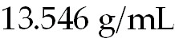 and the density of methylene chloride is 1.325 g/mL.
A) 0.00929 L
B) 0.0613 L
C) 9.71 L
D) 18.1 L
Answer: C
Diff: 2 Var: 5
Topic: Section 1.7 Derived Units: Density and Its Measurement
Learning Obj: LO 1.10a Calculate mass, volume, or density using the formula for density.
Global Obj: G4 Demonstrate the quantitative skills needed to succeed in chemistry.
39) A 3.20 g sample of pyrite (density = 4.5 g /mL0) is placed into a graduated cylinder with 15.64 mL of water. What will be the new volume of water?
A) 30.04
B) 14.93
C) 16.35
D) 0.71 mL
Answer: C
Diff: 2 Var: 4
Topic: Section 1.7 Derived Units: Density and Its Measurement
Learning Obj: LO 1.10a Calculate mass, volume, or density using the formula for density.
Global Obj: G4 Demonstrate the quantitative skills needed to succeed in chemistry.

40) A piece of metal ore weighs 7.25 g. When a student places it into a graduated cylinder containing water, the liquid level rises from 21.25 mL to 25.00 mL. What is the density of the ore?
A) 0.281 g/mL
B) 0.141 g/mL
C) 1.93 g/mL
D) 3.21 g/mL
Answer: C
Diff: 2 Var: 50+
Topic: Section 1.7 Derived Units: Density and Its Measurement
Learning Obj: LO 1.10a Calculate mass, volume, or density using the formula for density.
Global Obj: G4 Demonstrate the quantitative skills needed to succeed in chemistry.

41) A mass of mercury occupies 0.650 L. What volume would an equal mass of ethanol occupy? The density of mercury is and the density of ethanol is 0.789 g/mL.
A) 0.0378 L
B) 0.650 L
C) 11.2 L
D) 5.00 L
Answer: C
Diff: 2 Var: 50
Topic: Section 1.7 Derived Units: Density and Its Measurement
Learning Obj: LO 1.10a Calculate mass, volume, or density using the formula for density.
Global Obj: G4 Demonstrate the quantitative skills needed to succeed in chemistry.

42) Calculate the kinetic energy of a 150-g baseball moving at a speed of 38. m/s (85 mph).
A) 5.7 J
B) 1.1 × 102 J
C) 5.7 × 103 J
D) 1.1 × 105 J
Answer: B
Diff: 3 Var: 5
Topic: Section 1.8 Derived Units: Energy and Its Measurement
Learning Obj: LO 1.12 Calculate the kinetic energy of a moving object.
Global Obj: G4 Demonstrate the quantitative skills needed to succeed in chemistry.
43) The nutritional calorie (abbreviated Cal) is equal to
A) 1 mcal.
B) 4.184 J.
C) 4.184 Mcal.
D) 1 kcal.
Answer: D
Diff: 1 Var: 50+
Topic: Section 1.8 Derived Units: Energy and Its Measurement
Learning Obj: LO 1.13 Convert between common energy units.
Global Obj: G1 Demonstrate an understanding of the principles of scientific inquiry.

44) Which is the largest amount of heat?
A) 547 cal
B) 8.32 × 102 kcal
C) 6.66 × 102 J
D) 4.33 kJ
Answer: D
Diff: 2 Var: 50+
Topic: Section 1.8 Derived Units: Energy and Its Measurement
Learning Obj: LO 1.13 Convert between common energy units.
Global Obj: G4 Demonstrate the quantitative skills needed to succeed in chemistry.

45) Which of the following numbers has the greatest number of significant figures?
A) 0.8010
B) 0.504
C) 742000
D) 9.05 × 1024
Answer: A
Diff: 1 Var: 5
Topic: Section 1.9 Accuracy, Precision and Significant Figures in Measurement
Learning Obj: LO 1.14 Specify the number of significant figures in a measurement.
Global Obj: G4 Demonstrate the quantitative skills needed to succeed in chemistry.

46) How many of the following numbers contain 3 significant figures?

0.509 1.050 0.0500 1.06 × 1024

A) one
B) two
C) three
D) four
Answer: C
Diff: 1 Var: 5
Topic: Section 1.9 Accuracy, Precision and Significant Figures in Measurement
Learning Obj: LO 1.14 Specify the number of significant figures in a measurement.
Global Obj: G4 Demonstrate the quantitative skills needed to succeed in chemistry.
47) A methane molecule contains 1 atom of carbon. The number 1 represents how many significant figures?
A) one
B) two
C) three
D) infinite
Answer: D
Diff: 1 Var: 5
Topic: Section 1.9 Accuracy, Precision and Significant Figures in Measurement
Learning Obj: LO 1.16 Report a measurement to the appropriate number of significant figures.
Global Obj: G2 Demonstrate the ability to think critically and employ critical thinking skills.

48) A student measured the diameter of a sphere and determined the average value. His measurements are 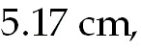 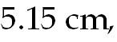 and 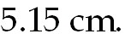 If the true diameter is 6.18 cm, what can be said about the student's results?
A) It is accurate and precise.
B) It is accurate but not precise.
C) It is precise but not accurate.
D) It is neither precise nor accurate.
Answer: C
Diff: 1 Var: 50+
Topic: Section 1.9 Accuracy, Precision and Significant Figures in Measurement
Learning Obj: LO 1.15 Evaluate the level of accuracy and precision in a data set.
Global Obj: G2 Demonstrate the ability to think critically and employ critical thinking skills.

49) Which of the following numbers has the greatest number of significant figures?
A) 0.5070
B) 0.201
C) 234000
D) 3.69 × 1024
Answer: A
Diff: 1 Var: 50+
Topic: Section 1.9 Accuracy, Precision and Significant Figures in Measurement
Learning Obj: LO 1.14 Specify the number of significant figures in a measurement.
Global Obj: G4 Demonstrate the quantitative skills needed to succeed in chemistry.

50) Which of the following is an exact number?
A) 0.0.369 grams
B) 9.25 liters
C) 4 oranges
D) 3.60°C
Answer: C
Diff: 1 Var: 50+
Topic: Section 1.9 Accuracy, Precision and Significant Figures in Measurement
Learning Obj: LO 1.14 Specify the number of significant figures in a measurement.
Global Obj: G2 Demonstrate the ability to think critically and employ critical thinking skills.
51) The measured mass of a sample of iron was 1.88 g. Which digit in the measurement has the least certainty?
A) the first digit, 1
B) the middle digit, 8
C) the last digit, 8
D) They are all certain digits.
Answer: C
Diff: 1 Var: 50+
Topic: Section 1.9 Accuracy, Precision and Significant Figures in Measurement
Learning Obj: LO 1.14 Specify the number of significant figures in a measurement.
Global Obj: G2 Demonstrate the ability to think critically and employ critical thinking skills.

52) How many of the following numbers contain 3 significant figures?

0.105 5.600 0.0300 7.00 × 102

A) one
B) two
C) three
D) four
Answer: C
Diff: 1 Var: 50+
Topic: Section 1.9 Accuracy, Precision and Significant Figures in Measurement
Learning Obj: LO 1.14 Specify the number of significant figures in a measurement.
Global Obj: G2 Demonstrate the ability to think critically and employ critical thinking skills.

53) A heptane molecule contains 16 atoms of hydrogen. The number 16 represents how many significant figures?
A) one
B) two
C) three
D) infinite
Answer: D
Diff: 1 Var: 9
Topic: Section 1.9 Accuracy, Precision and Significant Figures in Measurement
Learning Obj: LO 1.13 Convert between common energy units.
Global Obj: G2 Demonstrate the ability to think critically and employ critical thinking skills.
54) Consider the calculation:

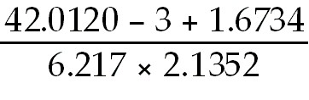

Which of the following is the answer to this question with the correct number of significant digits?
A) 3
B) 3.0189
C) 3.019
D) 3.0
Answer: A
Diff: 2 Var: 5
Topic: Section 1.10 Rounding Numbers
Learning Obj: LO 1.17 Report the answer of mathematical calculations to the correct number of significant numbers.
Global Obj: G4 Demonstrate the quantitative skills needed to succeed in chemistry.

55) How many significant figures are there in the answer to the following problem?

(3.335 × 6.500) + 0.940 = ?

A) one
B) two
C) three
D) four
Answer: D
Diff: 2 Var: 5
Topic: Section 1.10 Rounding Numbers
Learning Obj: LO 1.17 Report the answer of mathematical calculations to the correct number of significant numbers.
Global Obj: G4 Demonstrate the quantitative skills needed to succeed in chemistry.

56) How many significant figures are there in the answer for the following problem?

23.1 + 0.5588 + 17 = ?

A) one
B) two
C) three
D) four
Answer: B
Diff: 2 Var: 5
Topic: Section 1.10 Rounding Numbers
Learning Obj: LO 1.17 Report the answer of mathematical calculations to the correct number of significant numbers.
Global Obj: G4 Demonstrate the quantitative skills needed to succeed in chemistry.
57) How many significant figures are there in the answer for the following problem?

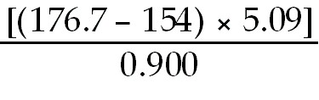 = ?

A) one
B) two
C) three
D) four
Answer: B
Diff: 2 Var: 5
Topic: Section 1.10 Rounding Numbers
Learning Obj: LO 1.17 Report the answer of mathematical calculations to the correct number of significant numbers.
Global Obj: G4 Demonstrate the quantitative skills needed to succeed in chemistry.

58) How many significant figures are there in the answer for the following problem?

23.1 + 0.5848 + 11 = ?

A) one
B) two
C) three
D) four
Answer: B
Diff: 2 Var: 50+
Topic: Section 1.10 Rounding Numbers
Learning Obj: LO 1.17 Report the answer of mathematical calculations to the correct number of significant numbers.
Global Obj: G4 Demonstrate the quantitative skills needed to succeed in chemistry.

59) Round off 00507506 to four significant figures.
A) 0051
B) 5076
C) 5100
D) 5.075 × 105
Answer: D
Diff: 1 Var: 5
Topic: Section 1.10 Rounding Numbers
Learning Obj: LO 1.17 Report the answer of mathematical calculations to the correct number of significant numbers.
Global Obj: G4 Demonstrate the quantitative skills needed to succeed in chemistry.
60) Round off 477,503 to four significant figures.
A) 4775
B) 4776
C) 4.775 × 105
D) 4.776 × 105
Answer: C
Diff: 1 Var: 50+
Topic: Section 1.10 Rounding Numbers
Learning Obj: LO 1.17 Report the answer of mathematical calculations to the correct number of significant numbers.
Global Obj: G4 Demonstrate the quantitative skills needed to succeed in chemistry.

61) Round off 327,504 to three significant figures.
A) 327
B) 328
C) 3.27 × 105
D) 3.28 × 105
Answer: D
Diff: 1 Var: 50+
Topic: Section 1.10 Rounding Numbers
Learning Obj: LO 1.17 Report the answer of mathematical calculations to the correct number of significant numbers.
Global Obj: G4 Demonstrate the quantitative skills needed to succeed in chemistry.

62) If 1.4% of the mass of a human body is calcium, how many kilograms of calcium are there in a 195-pound man?
A) 1.2 kg Ca
B) 6.0 kg Ca
C) 1.2 × 102 kg Ca
D) 6.0 × 102 kg
Answer: A
Diff: 3 Var: 5
Topic: Section 1.11 Calculations: Converting from One Unit to Another
Learning Obj: LO 1.19 Change a measurement into different units using appropriate conversion factors.
Global Obj: G4 Demonstrate the quantitative skills needed to succeed in chemistry and G5 Demonstrate an understanding of the impact of science on society.

63) A fishing boat accidentally spills 6.0 barrels of diesel oil into the ocean. Each barrel contains 42 gallons. If the oil film on the ocean is 2.5 × 102 nm thick, how many square meters will the oil slick cover?
A) 3.8 × 10-3 m2
B) 3.8 × 106 m2
C) 3.8 × 107 m2
D) none of these
Answer: B
Diff: 3 Var: 5
Topic: Section 1.11 Calculations: Converting from One Unit to Another
Learning Obj: LO 1.19 Change a measurement into different units using appropriate conversion factors.
Global Obj: G4 Demonstrate the quantitative skills needed to succeed in chemistry and G5 Demonstrate an understanding of the impact of science on society.
64) Because of the high heat and low humidity in the summer in Death Valley, California, a visitor requires about one quart of water for every two miles traveled on foot. Calculate the approximate number of liters required for a person to walk 15 kilometers in Death Valley.
A) 4.4 L
B) 18 L
C) 46 L
D) 70 L
Answer: A
Diff: 3 Var: 5
Topic: Section 1.11 Calculations: Converting from One Unit to Another
Learning Obj: LO 1.19 Change a measurement into different units using appropriate conversion factors.
Global Obj: G4 Demonstrate the quantitative skills needed to succeed in chemistry and G5 Demonstrate an understanding of the impact of science on society.

65) A car drives 80 km/h. If the car is driven for 122 minutes, how many miles has the car traveled?
A) 262
B) 364,000
C) 101
D) 24.4
Answer: C
Diff: 3 Var: 4
Topic: Section 1.11 Calculations: Converting from One Unit to Another
Learning Obj: LO 1.19 Change a measurement into different units using appropriate conversion factors.
Global Obj: G4 Demonstrate the quantitative skills needed to succeed in chemistry and G5 Demonstrate an understanding of the impact of science on society.

66) The output of a pendant manufacturer is 4335 pounds per week. If each pendant weighs 0.0133 pounds, how many pendants does the manufacturer make in one day?
A) 2,282,000
B) 324,700
C) 58
D) 46,560
Answer: A
Diff: 3 Var: 5
Topic: Section 1.11 Calculations: Converting from One Unit to Another
Learning Obj: LO 1.19 Change a measurement into different units using appropriate conversion factors.
Global Obj: G4 Demonstrate the quantitative skills needed to succeed in chemistry and G5 Demonstrate an understanding of the impact of science on society.

67) An atom can be seen by
A) an atomic force microscope.
B) a nucleon microscope.
C) an optical microscope.
D) a telescope.
Answer: A
Diff: 1 Var: 50+
Topic: Chapter 1 Inquiry - What are the Unique Properties of Nanoscale Materials?
Global Obj: G1 Demonstrate an understanding of the principles of scientific inquiry.
68) Identify the smallest item.
A) the width of human hair
B) a white blood cell
C) a virus
D) a sugar
Answer: D
Diff: 1 Var: 50+
Topic: Chapter 1 Inquiry - What are the Unique Properties of Nanoscale Materials?
Global Obj: G1 Demonstrate an understanding of the principles of scientific inquiry.

69) Liquids A, B, and C are insoluble in one another (i.e., they are immiscible). A, B, and C have densities of 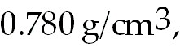 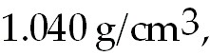 and 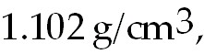 respectively. Which drawing represents the result of placing all three liquids into the same graduated cylinder?

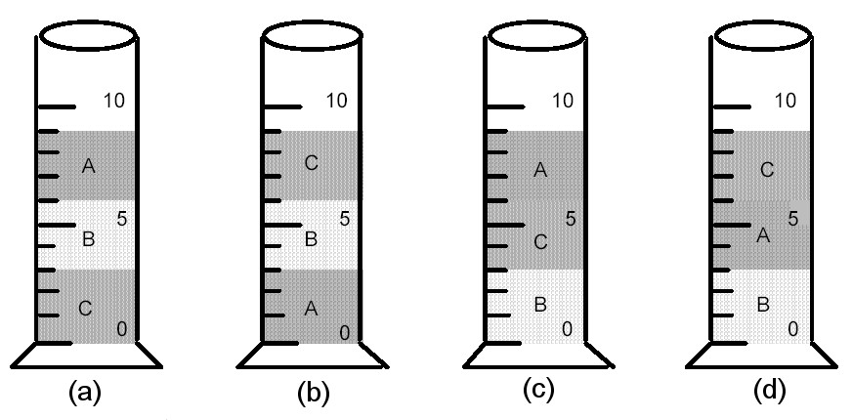

A) drawing (a)
B) drawing (b)
C) drawing (c)
D) drawing (d)
Answer: A
Diff: 2 Var: 50+
Topic: Conceptual Problems
Learning Obj: LO 1.11 Predict whether a substance will float or sink in another substance based on density.
Global Obj: G3 Read and interpret graphs and data.

1.3 Short Answer Questions

1) Chemistry is the study of the composition, properties, and transformations of ________.
Answer: matter
Diff: 2 Var: 1
Topic: Section 1.1 The Scientific Method in a Chemical Content: Improved Pharmaceutical Insulin
Learning Obj: LO 1.1 Identify the steps in the scientific method.
Global Obj: G1 Demonstrate an understanding of the principles of scientific inquiry.

2) A preliminary explanation of the results of many experiments that can be used to make predictions and suggest further experimentations is a ________.
Answer: hypothesis
Diff: 2 Var: 1
Topic: Section 1.1 The Scientific Method in a Chemical Content: Improved Pharmaceutical Insulin
Learning Obj: LO 1.1 Identify the steps in the scientific method.
Global Obj: G1 Demonstrate an understanding of the principles of scientific inquiry.
3) Using exponential notation, there are ________ bytes of memory are contained in a 2 TB external hard drive.
Answer: 2 × 1012
Diff: 2 Var: 1
Topic: Section 1.2 Experimentation and Measurement
Learning Obj: LO 1.3 Write numbers in scientific notation and use prefixes for multiples of SI units.
Global Obj: G4 Demonstrate the quantitative skills needed to succeed in chemistry.

4) Using exponential notation, there are ________ g in 1.5 mg.
Answer: 1.5 × 10-3-
Diff: 2 Var: 50+
Topic: Section 1.2 Experimentation and Measurement
Learning Obj: LO 1.3 Write numbers in scientific notation and use prefixes for multiples of SI units.
Global Obj: G4 Demonstrate the quantitative skills needed to succeed in chemistry.

5) The fundamental SI unit of mass is the ________.
Answer: kilogram
Diff: 2 Var: 1
Topic: Section 1.3 Mass and Its Measurement
Global Obj: G1 Demonstrate an understanding of the principles of scientific inquiry.

6) The meter is closest in length to the English system unit the ________.
Answer: yard
Diff: 2 Var: 1
Topic: Section 1.4 Length and Its Measurement
Learning Obj: LO 1.6 Convert between different prefixes used in length measurements.
Global Obj: G1 Demonstrate an understanding of the principles of scientific inquiry.

7) The difference between the boiling point and freezing point of water is 100°C, which is ________ kelvins.
Answer: 100
Diff: 2 Var: 1
Topic: Section 1.5 Temperature and Its Measurement
Learning Obj: LO 1.7 Convert between common units of temperature measurements.
Global Obj: G4 Demonstrate the quantitative skills needed to succeed in chemistry.

8) Volume is a derived unit having the unit lengthx, where x = ________.
Answer: 3
Diff: 2 Var: 1
Topic: Section 1.6 Derived Units: Volume and Its Measurement
Global Obj: G1 Demonstrate an understanding of the principles of scientific inquiry.

9) The quantity 2.27 cm3 is the same as ________ mL.
Answer: 2.27
Diff: 2 Var: 50+
Topic: Section 1.6 Derived Units: Volume and Its Measurement
Learning Obj: LO 1.8 Convert between SI and metric units of volume.
Global Obj: G4 Demonstrate the quantitative skills needed to succeed in chemistry.
10) The density of lead is 11.3 g/cm3. The volume occupied by 227 g of lead is ________ cm3.
Answer: 20.1
Diff: 3 Var: 1
Topic: Section 1.7 Derived Units: Density and Its Measurement
Learning Obj: LO 1.10a Calculate mass, volume, or density using the formula for density.
Global Obj: G4 Demonstrate the quantitative skills needed to succeed in chemistry.

11) The density of mercury is 13.6 g/cm3. The mass of 38.0 cm3 of mercury is ________ g.
Answer: 517
Diff: 3 Var: 1
Topic: Section 1.7 Derived Units: Density and Its Measurement
Learning Obj: LO 1.10a Calculate mass, volume, or density using the formula for density.
Global Obj: G4 Demonstrate the quantitative skills needed to succeed in chemistry.

12) Stored energy is ________ energy, and energy of motion is ________ energy.
Answer: potential, kinetic
Diff: 2 Var: 1
Topic: Section 1.8 Derived Units: Energy and Its Measurement
Global Obj: G1 Demonstrate an understanding of the principles of scientific inquiry.

13) The nutritionist unit Calorie is equal to ________ calories.
Answer: 1000
Diff: 2 Var: 1
Topic: Section 1.8 Derived Units: Energy and Its Measurement
Learning Obj: LO 1.13 Convert between common energy units.
Global Obj: G1 Demonstrate an understanding of the principles of scientific inquiry.

14) ________ refers to how well a number of independent measurements agree with one another, whereas ________ refers to how close to the true value a given measurement is.
Answer: Precision, Accuracy
Diff: 2 Var: 1
Topic: Section 1.9 Accuracy, Precision and Significant Figures in Measurement
Learning Obj: LO 1.15 Evaluate the level of accuracy and precision in a data set.
Global Obj: G1 Demonstrate an understanding of the principles of scientific inquiry.

15) The number of significant digits in 0.01810 g is ________.
Answer: four
Diff: 2 Var: 50+
Topic: Section 1.9 Accuracy, Precision and Significant Figures in Measurement
Learning Obj: LO 1.14 Specify the number of significant figures in a measurement.
Global Obj: G4 Demonstrate the quantitative skills needed to succeed in chemistry.

16) The quantity 1.0857 qt rounded to two significant figures is ________ qt.
Answer: 1.1
Diff: 2 Var: 50+
Topic: Section 1.10 Rounding Numbers
Learning Obj: LO 1.18 Round a measurement to a specified number of significant figures.
Global Obj: G4 Demonstrate the quantitative skills needed to succeed in chemistry.
17) Given that 2.54 cm = 1 in, 350 in3 = ________ L.
Answer: 5.74
Diff: 2 Var: 1
Topic: Section 1.11 Calculations: Converting from One Unit to Another
Learning Obj: LO 1.19 Change a measurement into different units using appropriate conversion factors.
Global Obj: G4 Demonstrate the quantitative skills needed to succeed in chemistry.

